**Create a tabular model project**

In this module, you use Visual Studio with SQL Server Data Tools (SSDT) or Visual Studio 2017 with Microsoft Analysis Services Projects VSIX to create a new tabular model project at the 1400 compatibility level. Once your new project is created, you can begin adding data and authoring your model. This demo also gives you a brief introduction to the tabular model authoring environment in Visual Studio.

## **Prerequisites**

## This is the first demo in a tabular model authoring tutorial. To complete this, you need the AdventureWorksDW sample database deployed into your on-premises SQL Server Database.

## **Creating a new tabular model project**

#### To create a new tabular model project

1. In Visual Studio, on the **File** menu, click **New** > **Project**.
2. In the **New Project** dialog box, expand **Installed** > **Business Intelligence** > **Analysis Services**, and then click **Analysis Services Tabular Project**.
3. In **Name**, type **SalesDemo**, and then specify a location for the project files. By default, **Solution Name** is the same as the project name; however, you can type a different solution name.
4. Click **OK**.

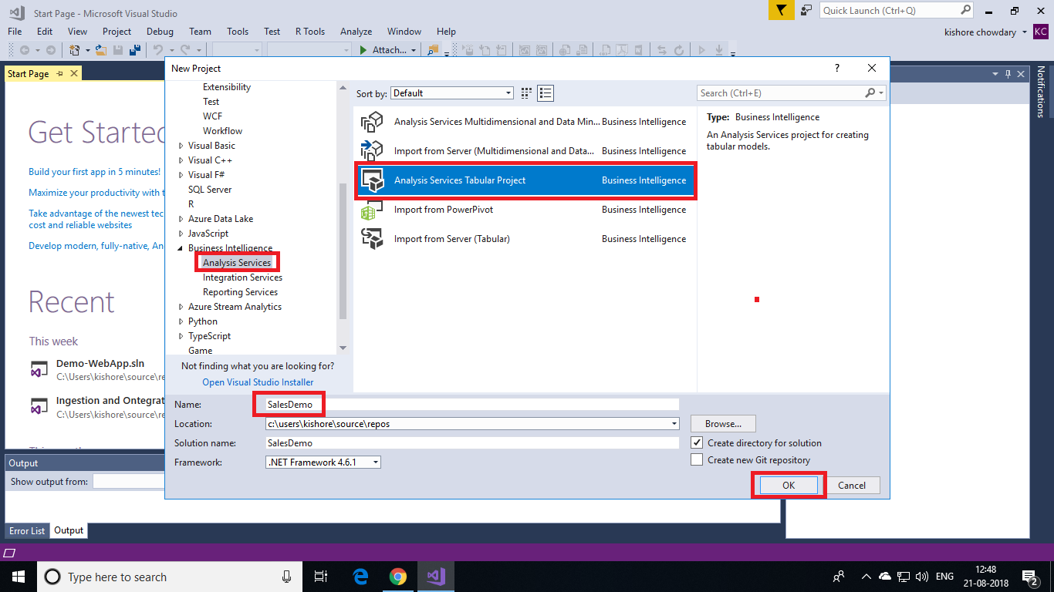

1. In the **Tabular model designer** dialog box, select **Integrated workspace**. The workspace hosts a tabular model database with the same name as the project during model authoring. Integrated workspace means Visual Studio uses a built-in instance, eliminating the need to install a separate Analysis Services server instance just for model authoring.
2. In **Compatibility level**, select **SQL Server 2017 / Azure Analysis Services (1400)**.

